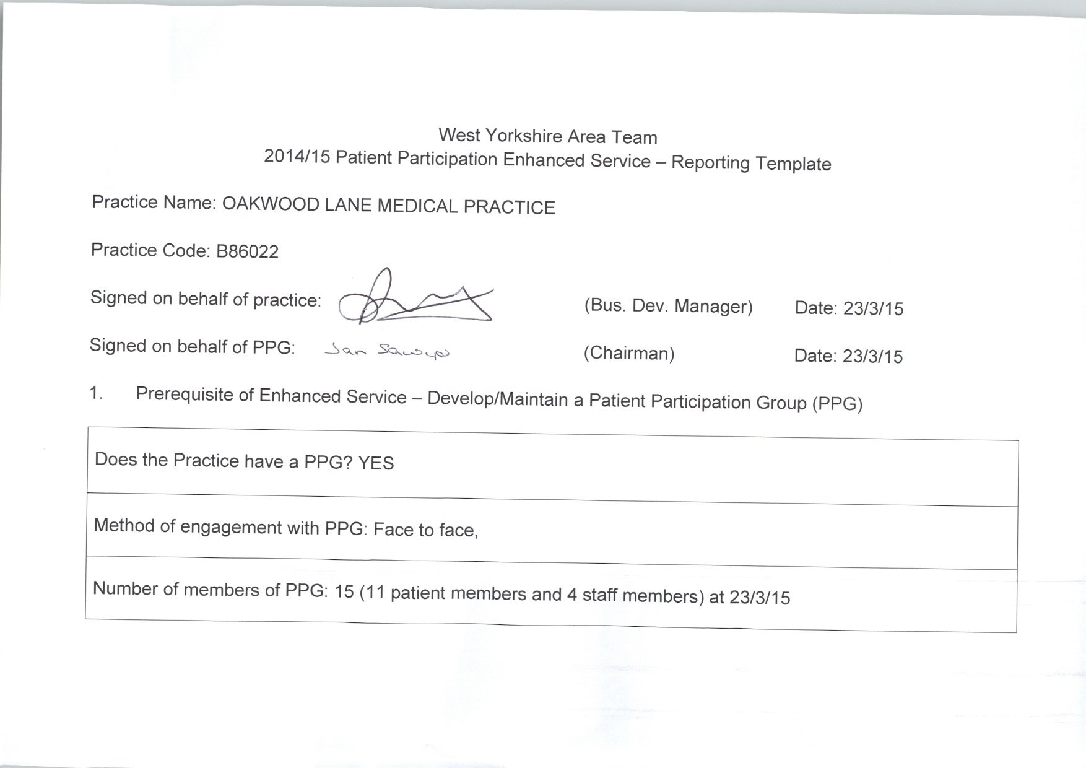
Detail the gender mix of practice population and PPG:  % Male Female  Practice 6325 6382  PRG 23% 40.61% | Detail of age mix of practice population and PPG:  % <16 17-24 25-34 35-44 45-54 55-64 65-74 > 75  Practic 285 1325 1831 1837 1700 1155 924 917  PRG 0 0 0 0.05% 0.18% 0.17% 0.32% 0.22%
Detail the ethnic background of your practice population and PRG:

 | White |  |  |  | Mixed/ multiple ethnic groups
 | British | Irish | Gypsy or Irish traveller | Other white | White &black Caribbean | White &black African | White &Asian | Other mixed
Practice | 5510 | 102 | 0 | 402 | 193 | 82 | 66 | 301
PRG | 9

 | Asian/Asian British |  |  |  |  | Black/African/Caribbean/Black British |  |  | Other
 | Indian | Pakistani | Bangladeshi | Chinese | Other  Asian | African | Caribbean | Other Black | Arab | Any other
Practice | 742 | 977 | 73 | 73 | 301 | 384 | 380 | 82 | 156 | 2883
PRG |  | 2

Describe steps taken to ensure that the PPG is representative of the practice population in terms of gender, age and ethnic background and other members of the practice population:

The Patient Participation Group in this Practice is known as the Patients Forum. Members actively seek representation from a mixed age range and a variety of ethnic groups. There is a dedicated Forum notice board in the waiting area advertising for new members specifically so that the group can better reflect the diversity of the Practice population. When the new purpose built surgery opened on 1st September 2014 Members met and welcomed patients during the first week, explaining the facilities and showing patients round. This gave the members an opportunity to encourage a diverse group of patients to join the Forum. Those that showed interest were invited to observe a meeting and meet current members before committing themselves. In addition, word of mouth through both the current members and Practice staff has helped in the search to increase diversity. Three members of the Forum resigned during the year; all white and two of them of retirement age, one a little younger. Two new members have joined the Forum during the year; one white and a lot younger, the other of Asian origin and of working age. Four further new members will join in April 2015, all of working age and one representing an ethnic minority.

Are there any specific characteristics of your practice population which means that other groups should be included in the PPG?
e.g. a large student population, significant number of jobseekers, large numbers of nursing homes, or a LGBT community? YES

If you have answered yes, please outline measures taken to include those specific groups and whether those measures were successful:

There are a large number of patients in residential and nursing homes, and many of these have various levels of dementia. Although we send patient questionnaires to a sample of residents in these homes we have never actively sought residents to join the Forum.

- Review of patient feedback

Outline the sources of feedback that were reviewed during the year:

The Forum reviews all comments from the Family & Friends Test and, in time, will make suggestions to improve care and services. The Forum has designed a patient questionnaire which was available for patients to complete during February 2015. It was distributed by a variety of methods to encourage as many people as possible to complete it: in surgery reception; sent by post to some patients who are harder to reach; sent to some patients who contact the surgery via email; and it was available on the Practice website. It is currently being analysed by the Forum and the survey results will be shared and discussed with the Practice.
Feedback has also been received during the first week that we opened, when Forum members spoke to patients in the Practice and comments and suggestions were given to the partners.
The Forum has also reviewed the complaints process and procedure with the Complaints Manager and a Partner. Suggestions for immediate action were made. The Practice Compliments and Complaints leaflet for patients was updated. This, and the process/procedure had originally been written by the Forum and approved for use by the Partners.

How frequently were these reviewed with the PRG?

The Forum, membership of which includes some staff members, meets every six weeks and regularly reviews the Practice’s activities. It aims to work in co-operation with the Practice to ensure that patients are at the centre of care and services being provided, and that the Practice is a centre of excellence for the patients it serves.

- Action plan priority areas and implementation

Priority area 1
Description of priority area:

The Forum has taken an interest in the design of the new health centre premises that opened on 1st September 2014, and the services to be provided within it.

What actions were taken to address the priority?

The Forum looked at draft designs and suggested alterations, of which a number were incorporated into the new building. It also suggested services to be provided in the building. The Practice already has ultrasound, bowel screening, a dementia clinic and a specialist clinic for patients with atrial fibrillation. Members would also have liked a podiatry service but this is not possible as there is a service provided at another surgery a short distance away. Nevertheless, as GP’s commission their own services the request from the Forum still stands.
The Forum used experts in the group to ensure, for example, the needs of partially sighted patients were considered in the design and colour schemes. Members ensured that doors were of suitable size for wheelchair access.

Result of actions and impact on patients and carers (including how publicised):

The Practice is really pleased that patients have found the premises user friendly and to date we have not received any criticism about the design or layout. However, some internal signage is too small, and a big sign is needed to indicate the car park behind the building. Consultation is ongoing about the use to be made by the community of the large room designated for this purpose upstairs.

Priority area 2
Description of priority area:

The Forum identified that the Practice needed to update the patient information leaflet and website.

What actions were taken to address the priority?

The Forum has helped the Practice update the patient information leaflet and plans to review the content on a regular basis in light of changes in the Practice, new instructions from NHS England, the new GP contract, or new regulations/Statutory Instruments.
The Practice website, which also provides information for Patients, is being reviewed and the Forum is helping the Practice with positive suggestions and implementation.

Result of actions and impact on patients and carers (including how publicised):

The leaflet is available in the surgery and the website is continually being improved. The Forum has noted the inflexibility of the external website designers and will work with the Practice to suggest how this can be overcome.

Priority area 3
Description of priority area:

Due to the continuing increase in demand for appointments and the Practice’s inability to meet this demand, the Practice went on to a partial version of the “Doctor First” system with agreement from the Forum to trial this in July 2014. The Forum works with the Practice to review and improve the appointment and telephone systems on an on-going basis.

What actions were taken to address the priority?

A working group has met, comprising Practice staff and Forum members, to look at how well the appointment system is working and to suggest improvements. Discussions about how to best allocate the appointments available between different time frames is ongoing urgently. This is also about patient education and how to determine what is an emergency; what is quite urgent but not an emergency; and what is routine and can wait for the next “routine” appointment. This is linked to the telephone system which currently has long waiting times to get through to a person.

Result of actions and impact on patients and carers (including how publicised):

The Forum is continuing to work with the Practice to see how the appointments available can be rebalanced. Together improvements will also be considered to the telephone system to ensure each call is answered promptly within a very short space of time.

Progress on previous years

If you have participated in this scheme for more than one year, outline progress made on issues raised in the previous year(s):
This is the first year that the forum has been asked to participate in this scheme, so is unable to comment on progress when it has not been party to issues raised in previous years. Some progress has been made to invite new members from diverse backgrounds to join the Forum, and this will continue to be an issue to be worked on in the future when there are vacancies.

- PPG Sign Off

Report signed off by PPG: YES

Date of sign off: 23/3/15

How has the practice engaged with the PPG?

There are four practice members of the Patient Forum representing management, admin, nursing and the Partners and the practice members are part of the forum and meet every six weeks with the patient members. Other members of the practice staff, including other Partners, also meet with patient members of the forum to progress specific working groups.

How has the practice made efforts to engage with seldom heard groups in the practice population?

The Practice has sent out patient questionnaires to patients who are housebound and has e-mailed patient questionnaires to some patients who do not always attend surgery. The Practice has recently started to work with “patient champions” and has approximately 30 volunteers, some of which represent seldom heard groups.

Has the practice received patient and carer feedback from a variety of sources?

The Practice has sent and handed out questionnaires to a varied selection of patients and carers and Forum members met and greeted patients during the first week that the new surgery opened. This has resulted in a feedback for the Practice. In addition we have been collecting and analysing Family and Friends comments from patients and we intend to use this feedback to produce patient information leaflets saying “you said” and “we did”.

Was the PPG involved in the agreement of priority areas and the resulting action plan?

The Forum suggests most items on the Forum’s agenda and decide which to prioritise. The Practice then works with the group to improve the services provided.

How has the service offered to patients and carers improved as a result of the implementation of the action plan?

The patients have a helped with suggestions for the Practice to provide a well-designed, patient friendly surgery.
The Forum is working with the Practice to improve the appointment system and the patient information leaflet and website.

